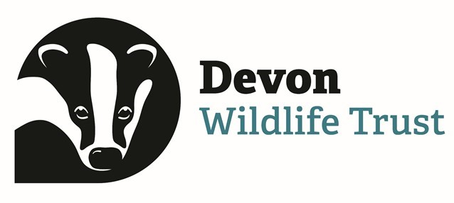
East Dartmoor Landscape Recovery Area
Flagship Species - Survey Update
The 2024 breeding season has seen a flurry of activity across the project area, with data being collected on many of the project’s flagship species. Our aim for this phase of the project (the Development Phase) has been to survey all suitable habitat for each species to learn more about the size and location of the current populations and, where relevant, to have more insight into different breeding territories.
Despite a very wet and windy spring, we were able to achieve almost 100% coverage of potential sites for both the willow tit and the Breeding Bird Survey. Results were mixed, with zero willow tit territories being detected even with some high-quality areas of habitat. The results from the Breeding Bird Survey, which focused on curlew, cuckoo, whinchat and snipe are still being analysed, but early findings suggest whinchat has continued to decline in the area, whilst the other three appear to be relatively stable compared to recent years.
Similarly for lesser spotted woodpeckers, we were very happy to have been able to survey all available habitat. However, due to poor weather and limited staff capacity, we were only able to ascertain the presence or absence of the species. We hope to run this survey again in spring 2025 to gather more detail on the number of territories.
We have been very lucky to garner the support of some incredible research groups and organisations that work within the project area. The Dartmoor Curlew Recovery Project, PiedFly.NET, Butterfly Conservation and Buglife are all sharing their data from their own surveys, and we are supporting that data collection where possible. For instance, whilst surveying for blue ground beetles with Buglife, we were very happy to find a new site for the beetle and we’ll be returning for hibernation surveys over the coming months to see if we can find a few more new sites to add to the list.
Looking forward, we hope to use the coming months to keep surveying for bryophytes (some new species have already been discovered for Devon!) and will develop our lichen monitoring plan. We will also use this time to review in more detail the 2024 breeding season results to understand how best to monitor our flagship species going forward and, where needed, how we can improve the habitat available to them.
A big thank you to all the volunteers who have provided not only their time, but their incredible knowledge, which has helped achieve so much this year. Another big thank you also goes to the partners and landowners involved for their continued support.
Emily Cuff
DWT Nature Recovery Officer

