Pine Martens Bounce Back
The Two Moors Pine Marten Project

Creative Commission application form

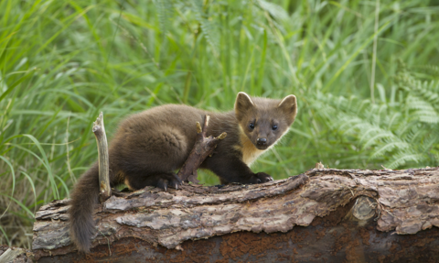
Photo: Mark Hamblin/2020VISION

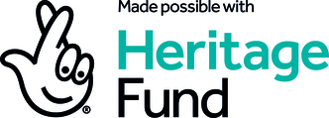

Please fill out this application form to apply for the creative commission opportunity as part of the Pine Martens Bounce Back: Two Morros Pine Marten project.
- Contact Name:

- Name of group/business/collective that you are representing:

- Address:

- Email address:

- Is this an individual or group proposal?

- Type of work (artwork for display, performance, workshop and display, sculptural installation, film, photography for example)

- Location of work:

- Concept Statement – please describe the visual appearance and audience experience you wish to realise (300 words)

- Describe how it meets the themes of the project (300 words)

- Outline how it meets the criteria – please be specific where possible including dimensions, spatial and installation requirements

- Provide a budget including:
- Artist fees
- Material costs
- Installation costs
- Transport costs

Please feel free to send a separate document if needed otherwise please provide and explain your budget here:

- Opportunities for additional income (please provide information about potential match/addition funding even if not confirmed)

- Provide details of previous experience (150 words)

- Please include any design or illustrations that will support your proposal when you send your completed application form.

Please submit your application along with any supporting documents to Katie Wilkinson, Wilder Communities Team Leader via email: kwilkinson@devonwildlifetrust.org
Please use ‘’PMBB Creative commission’’ in the subject line.
Closing date: Sunday 22nd September 2024

Pine Martens Bounce Back: The Two Moors Pine Project is made possible with support from The National Lottery Heritage Fund and with thanks to the National Lottery players. This project aims to restore healthy populations of pine martens to the South West of England.
